Answer
L2 : More about factorization (B)

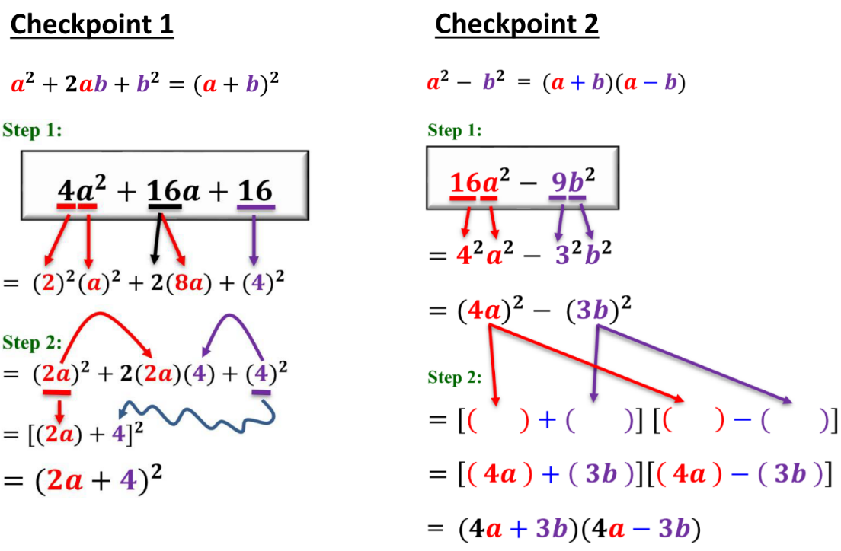

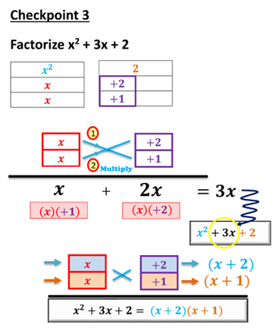

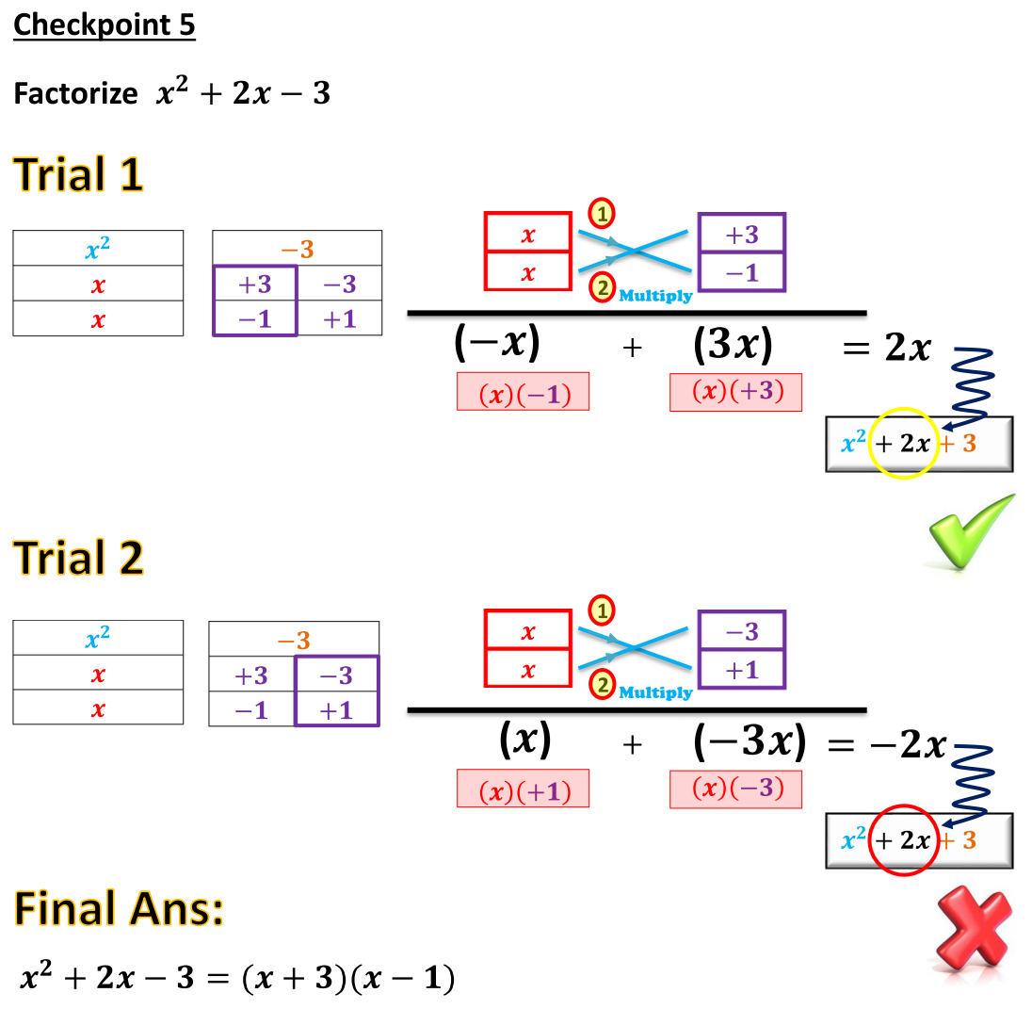

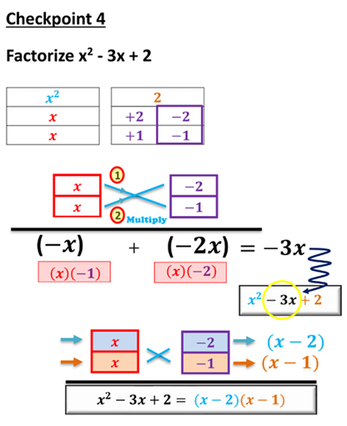



Let’s get started!

Factorize the following expressions.

1. a² + 24a + 95
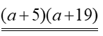

3. c² − 13c − 90
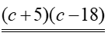

5. 66 + w² + 17w

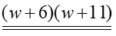

7. −32 − 4h + h²

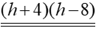

9. 15p − p² − 44

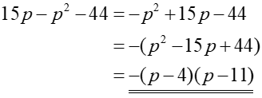

11. 2s² − 26s + 72

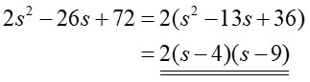

2. b² − 48b + 176
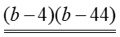

4. d ² + 17d − 200

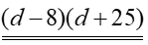

6. −6s + s² − 91

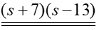

8. −42 + 11r + r²
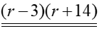

10. −17n − n² − 72

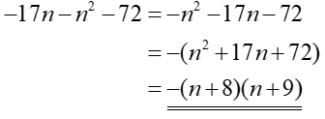

12. 3t² − 12t − 63

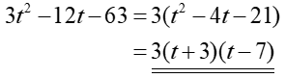

Factorize the following expressions.
13. 7x² − 10x + 3

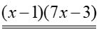

15. 4c² + 9c + 2

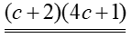

17.

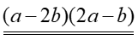

19. $\text{5}f^{\text{2}}+\text{24}fg+\text{16}g^{\text{2}}$

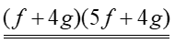

21. (a)
(b)

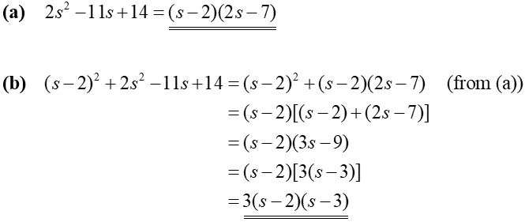

23. (a) 7m² + 16mn + 4n²
(b) 7m² + 16mn + 4n² + 5m + 10n

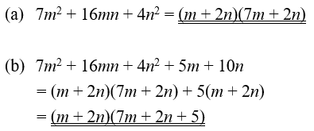

14. 5y² − 11y + 2

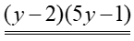

16. 4s² − 11s + 6

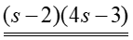

18. $\text{3}p^{\text{2}}-\text{8}pq+\text{5}q^{\text{2}}$
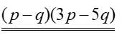

20.

(2s + 3t)(3s + 4t)

22. (a)
(b)

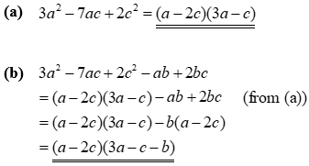

24. (a) x² – 8x + 12
(b) xy – x² – 6y + 8x – 12

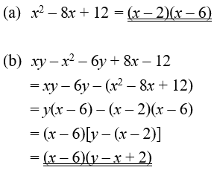

Factorize the following expressions.
25. 4a² + 16a − 9

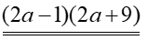

27. 22c² − 67c + 30

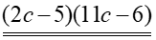

29. 21a² − 8ab − 4b²

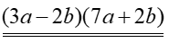

31. $\text{10}p^{\text{2}}+\text{9}pq-\text{7}q^{\text{2}}$
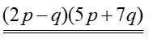

33. 7m³n – 41m²n² – 6mn³

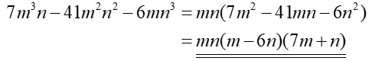

35. (a) 18x² – 3xy – 10y²
(b) 24x – 20y – 18x² + 3xy + 10y²

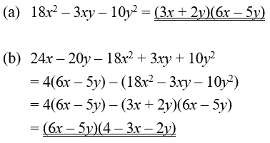

26. 24b² − b − 10

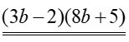

28. 9d ² − 4d − 5

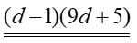

30. 4m² + 4mn − 15n²

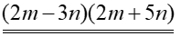

32.

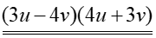

34. 60b² – 24b⁴ + 4b³

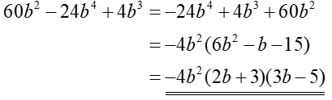

36. (a) x²y – 4xy² – 32y³
(b) x²y + 2x² + 16xy – 4xy² + 32y² – 32y³

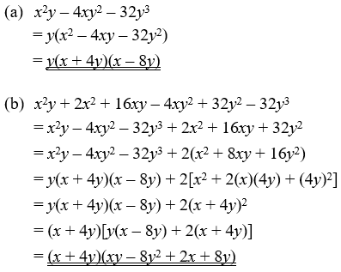

Factorize the following expressions.
37.

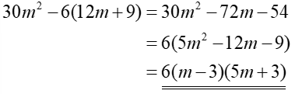

39. (9p − 12)(6p + 6) − 15p

(9p − 12)(6p + 6) − 15p
= 54p² + 54p − 72p − 72 − 15p
= 54p² − 33p − 72
= 3(18p² − 11p − 24)
= 3(2p − 3)(9p + 8)

41.

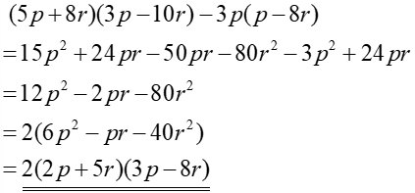

43.

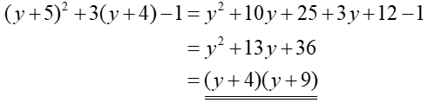

$${ \left(y+\text{5}\right)}^{\text{2}}+\text{3}\left(y+\text{5}\right)-\text{4} \\ =\left[\left(y+\text{5}\right)+\text{4}\right]\left[\left(y+\text{5}\right)-\text{1}\right] \\ =\left(y+\text{9}\right)\left(y+\text{4}\right)$$

45.

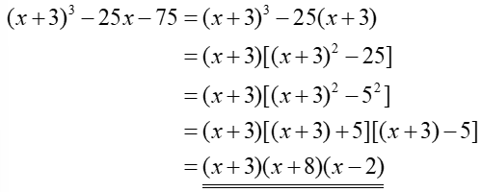

38. .

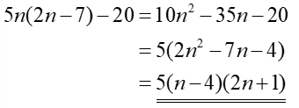

40.
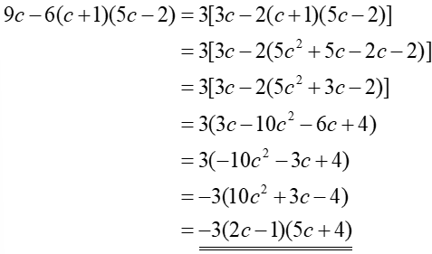

42.

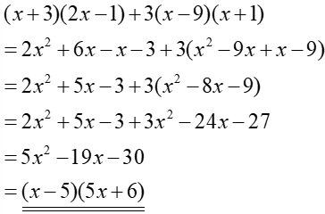

44.

$${ \left(z-\text{6}\right)}^{\text{2}}+\text{2}\left(z-\text{6}\right) \\ =\left(z-\text{6}\right)\left[\left(z-\text{6}\right)+\text{2}\right] \\ =\left(z-\text{6}\right)\left(z-\text{4}\right)$$

46.

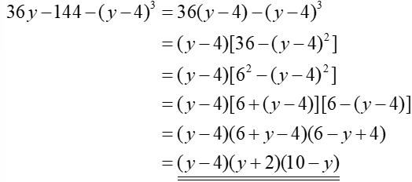

47. Factorize
(a) ,
(b) ,
(c)

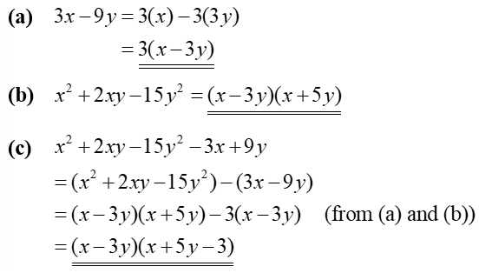

49. Factorize
(a) ,
(b) ,
(c) .

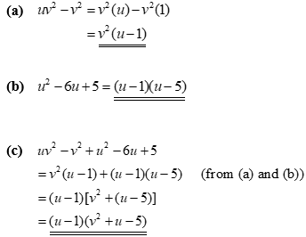

51. Factorize
(a) ,
(b) ,
(c) .

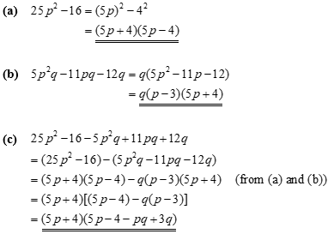

48. Factorize
(a) ,
(b) ,
(c) .

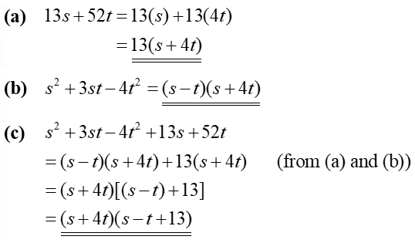

50. Factorize
(a) ,
(b) ,
(c) .

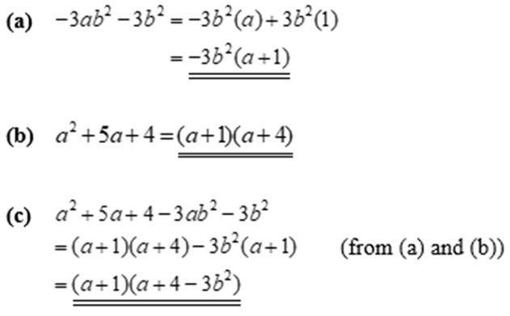

52. Factorize
(a) ,
(b) ,
(c) .

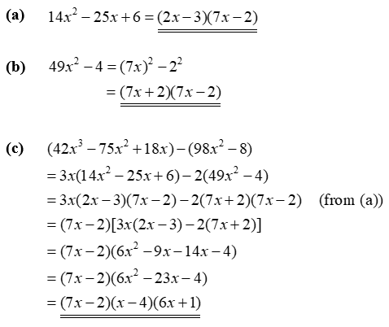

Final Boss!

53. (a) Factorize .
(b) Hence, factorize
(i) ,
(ii) .

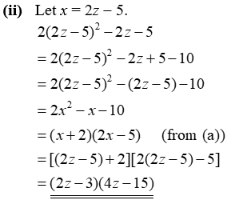
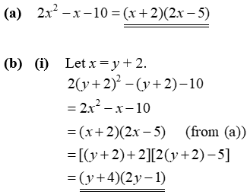

55. (a) Factorize .
(b) Hence, factorize .

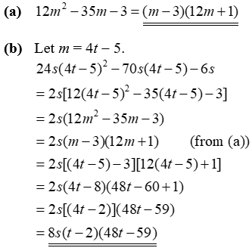

57. (a) Factorize .
(b) Hence, factorize .

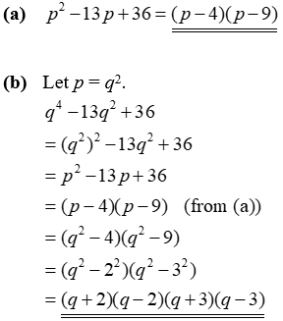

54. (a) Factorize .
(b) Hence, factorize
(i) ,
(ii) .

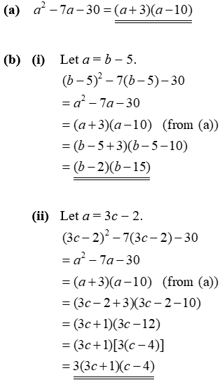


56. (a) Factorize .
(b) Hence, factorize .

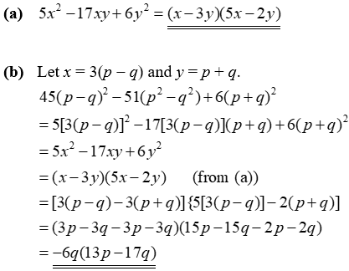

58. (a) Factorize .
(b) Hence, factorize .

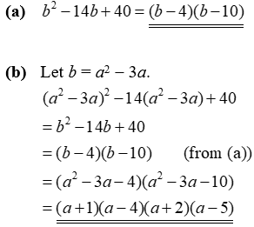

59. (a) Factorize .
(b) Hence, factorize .

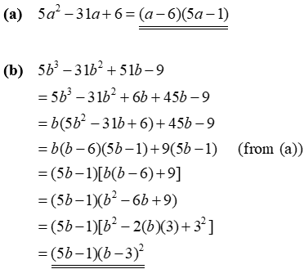

61. (a) Factorize .
(b) Hence, simplify .

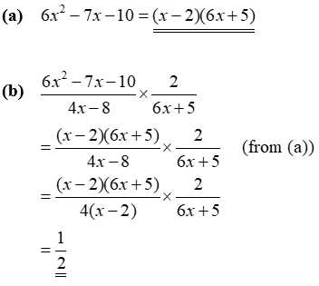

63. (a) Factorize .
(b) Hence, simplify .

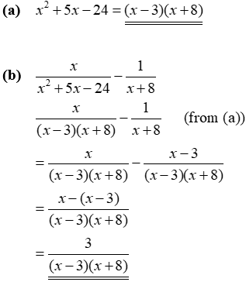

60. (a) Factorize .
(b) Hence, factorize .

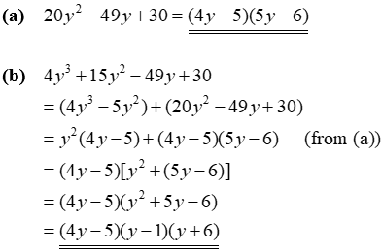

62. (a) Factorize
(i) ,
(ii) .
(b) Hence, simplify .

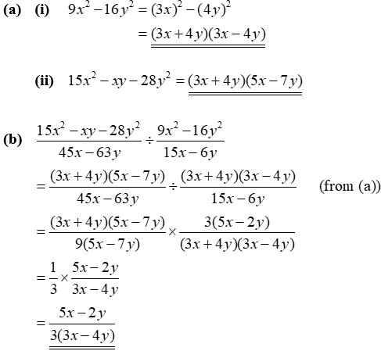

64. (a) Factorize .
(b) Hence, simplify .

